**DEVELOPING a comprehensive library that provides fundamental of a company SUCH AS debt, holdings, total revenue, net income, pay-out ratio, annual report based on past data.**

The stock market broadly refers to the collection of exchanges and other venues where the buying, selling of shares of publicly held companies take place. As stock market is an investment way where thousands of risks are involved. And most of the people are afraid to invest under stock market because of the uncertainty in stock market. There are more than 5000+ companies listed under Indian stock market. A new comer can never guess to invest when and in which company as time is the key to investment. So, here we come with a solution where our website will be a helping hand to the people who want to invest. The website will be showing the fundamentals of a company which are necessary for an investor to know.

You must have a doubt that why will anybody require this information as there are many risks involved in stock market. Let me show you the growth of the market in past 40 years:

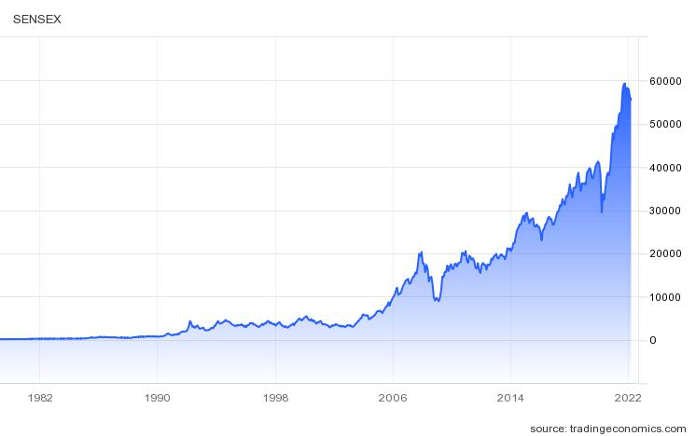

Out of the country's population of 136 crore people, roughly 4.3 per cent of Indians have the financial firepower to invest in the markets. When more people will participate in the market, there will be a gradual shift in the economy, businesses will flourish, GDP will increase, the market will expand. India needs to have strong financial markets to become a developed economy.

So, through this website we have a motive to educate people and make investment a source of passive income.

TECH STACK USED IN THE PROJECT ARE :-

* HTML
* CSS